1. Sequential API
✅ What it is
The Sequential API is the simplest way to build neural networks where layers are stacked one after another in a linear sequence.
👉 Think of it like a straight pipeline:
Input → Layer1 → Layer2 → Layer3 → Output

✅ Key Characteristics
- Linear stack of layers
- One input tensor
- One output tensor
- No branching or merging
- Easy to build and understand
- Good for beginners and simple models

✅ How it Works (Conceptually)
Each layer’s output becomes the next layer’s input automatically.
Example flow:
Input layer
↓
Dense layer
↓
Activation layer
↓
Output layer

✅ Example Architecture
Simple ANN:
- Input Layer
- Hidden Layer 1
- Hidden Layer 2
- Output Layer

✅ When to Use Sequential API
Use it when:
- Model has single input & single output
- Layers follow one straight order
- No skip connections
- No multiple branches
Examples:
- Simple ANN
- Basic CNN
- Linear classification models

✅ Advantages
- Very easy syntax
- Beginner-friendly
- Fast to implement
- Less code

❌ Limitations
- Cannot handle:
  - Multiple inputs
  - Multiple outputs
  - Residual connections
  - Complex architectures
  - Shared layers

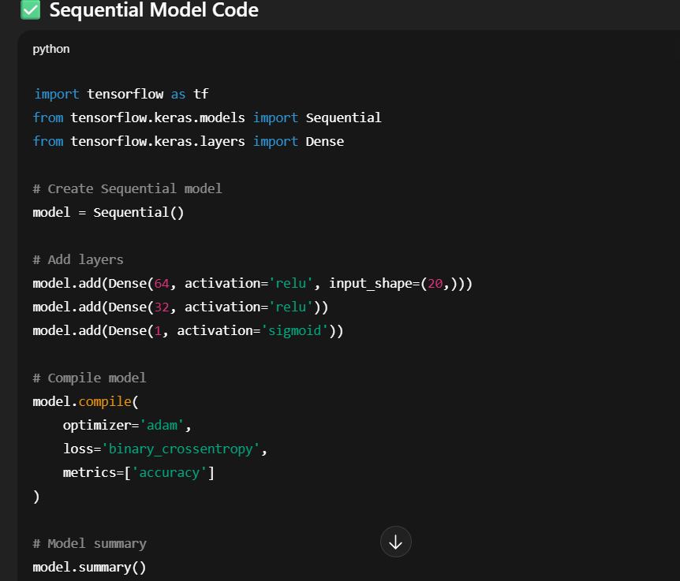
Explanation
- Sequential() → creates linear stack
- First layer needs input_shape
- Each layer automatically feeds next layer
- Good for straight architecture
Flow:
Input(20 features)
↓
Dense(64)
↓
Dense(32)
↓
Output(1)
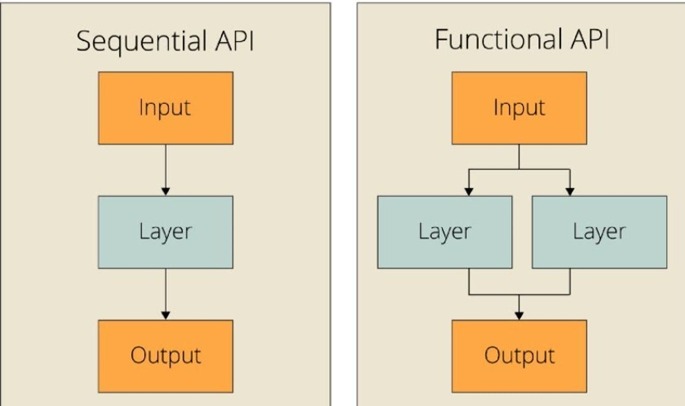
🔹 2. Functional API
✅ What it is
The Functional API allows you to create complex neural network architectures where layers are treated like functions.
👉 Instead of a straight line, you create a graph structure.
Example:
→ Layer2 →
Input → Layer1 → Merge → Output
→ Layer3 →

✅ Key Characteristics
- Flexible architecture
- Supports multiple inputs
- Supports multiple outputs
- Supports branching
- Supports layer sharing
- Supports non-linear connections

✅ How it Works (Conceptually)
You explicitly define:
- Input layer
- Layer connections
- Model inputs & outputs
Each layer is applied like a function:
output = layer(input)

✅ Example Architectures Possible
- Multi-input models
- Multi-output models
- Residual Networks (ResNet)
- Siamese Networks
- Attention models
- Encoder-Decoder models

✅ When to Use Functional API
Use it when:
- Model has complex structure
- Multiple input sources
- Multiple outputs
- Need skip connections
- Need layer reuse
Examples:
- Image captioning
- NLP transformer models
- Recommendation systems
- Autoencoders

✅ Advantages
- Extremely flexible
- Production-level modeling
- Clear architecture visualization
- Supports advanced deep learning models

❌ Limitations
- Slightly harder for beginners
- More code required
- Need to define data flow manually

✅ Functional Model Code
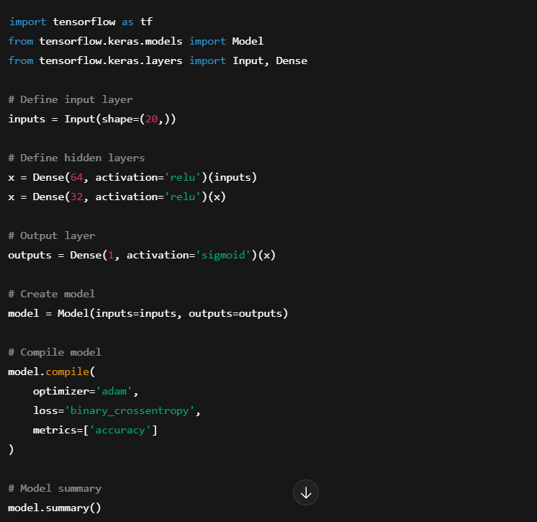

What Exactly Is x?
In the Keras Functional API:
x = Dense(...)(inputs)
- Dense(...) → creates a layer object
- (inputs) → applies that layer
- The result → a tensor
So:
x
is a Keras Tensor object, not a function.

When you write:
x = Dense(32, activation='relu')(x)
You are:
- Taking previous tensor x
- Passing it to next layer
- Getting a new tensor
- Reassigning it to x
So x keeps getting updated with the new tensor at each layer.

What Type Is x?
If you check:
print(type(x))
You’ll see something like:
keras.engine.keras_tensor.KerasTensor
That means:
✔ It represents the output of that layer
✔ It stores shape information
✔ It stores graph connections
✔ It is part of the computational graph

🔹 3. Key Differences (Very Important for Interviews)
Feature | Sequential API | Functional API
Architecture | Linear | Graph-based
Complexity | Simple | Complex
Inputs | Single | Multiple allowed
Outputs | Single | Multiple allowed
Branching | Not supported | Supported
Layer Sharing | Not supported | Supported
Skip Connections | Not possible | Possible
Flexibility | Low | High
Learning Curve | Easy | Moderate
Use Case | Basic models | Advanced models

When Functional API Becomes Powerful
Example: Suppose you want:
- Two inputs (e.g., numeric + text features)
- Or skip connections (ResNet style)
- Or multiple outputs (predict risk + interest rate)
Sequential cannot do this.
Example:
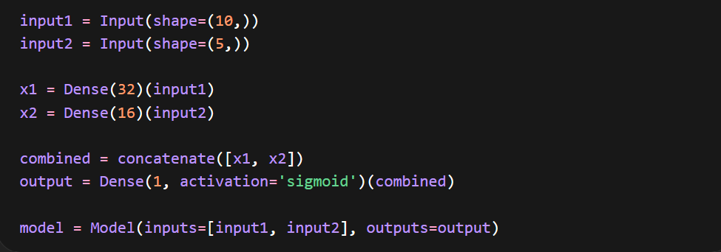

Why (10,) Has a Comma?
Very important Python concept:
- (10) → just integer 10
- (10,) → tuple with one element
Keras expects a tuple.
When training such a model, you must pass inputs like this:
model.fit([X1_train, X2_train], y_train)

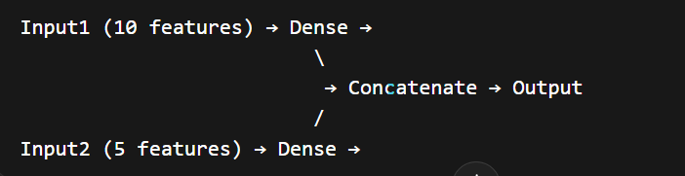
This is impossible with Sequential.

🧠 Architecture Perspective
Sequential = Stack of layers
Like stacking bricks vertically.
Functional = Directed Graph
You define how tensors flow.

1️⃣ Multiple Outputs Example
🎯 Scenario:
In a loan model, you want to predict:
- ✅ Loan Approval (0 or 1)
- ✅ Risk Score (continuous value)
That means one input → two outputs

❌ Sequential API (Not Possible)
Sequential only allows:
Input → Layer → Layer → One Output
It cannot branch into two different outputs.

✅ Functional API (Possible)
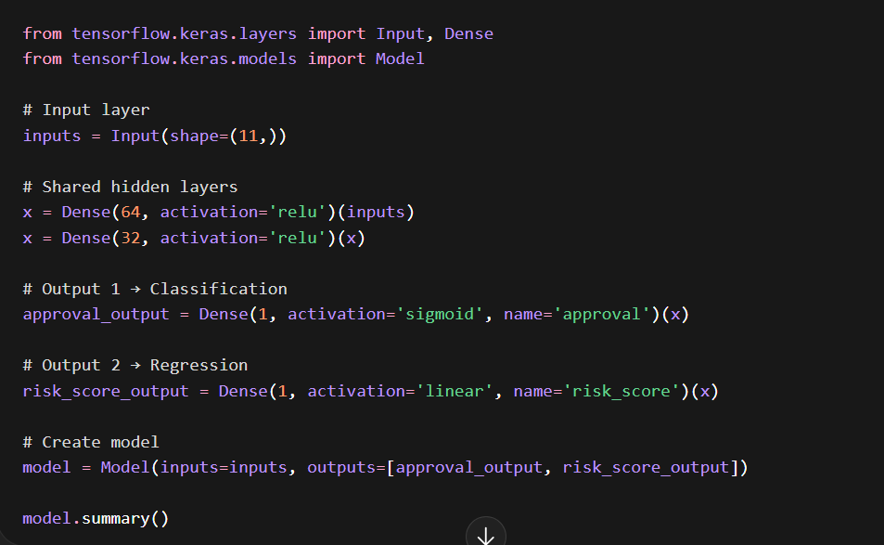

Architecture looks like:
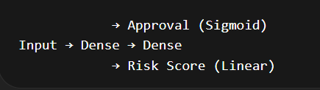

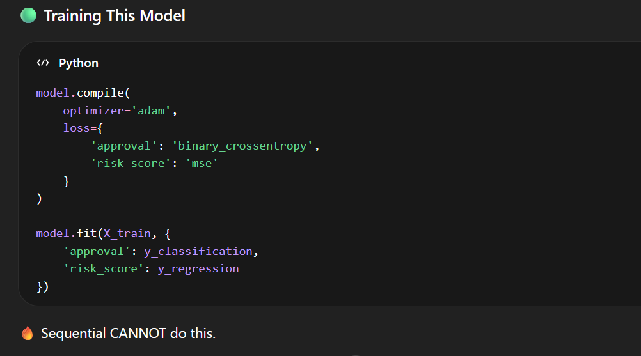

2️⃣ Skip Connection Example (ResNet Style)
🎯 What is Skip Connection?
Instead of:
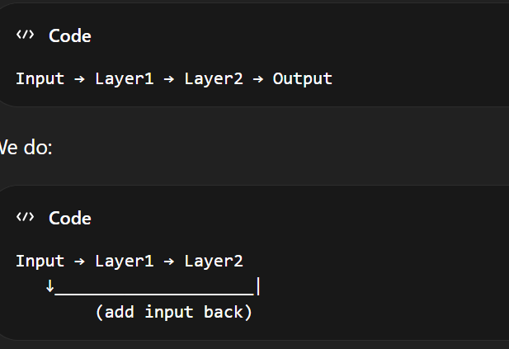

This helps avoid vanishing gradient problem.
Used in:
- ResNet
- Deep CNNs
- Transformers

❌ Sequential (Not Possible)
Sequential only stacks layers vertically.
No way to add previous layer manually.

✅ Functional API Skip Connection Example
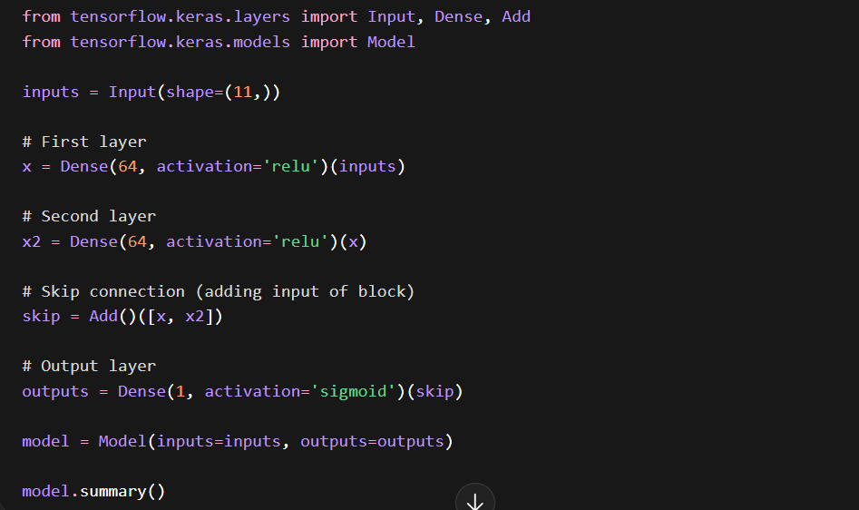

Why Skip Connections Are Powerful
Without skip:
Deep network → vanishing gradient → stops learning
With skip:
Gradient flows directly backward
Training becomes stable
That’s why ResNet won ImageNet.

🎯1️⃣ What is Add()?
✅ Purpose:
Used to add two or more tensors element-wise.
Example:
from keras.layers import Add
added = Add()([tensor1, tensor2])
What it does mathematically:
$$Output=tensor1+tensor2$$
⚠ Important:
- Shapes must be the SAME.

🔷 Where is it used?
✔ Skip Connections (Residual Networks)
Used in architectures like ResNet
Why?
- Helps avoid vanishing gradient
- Allows deeper networks
- Improves training stability

🔷 2️⃣ What is Concatenate()?
✅ Purpose:
Used to join tensors along a dimension.
Example:
from keras.layers import Concatenate
merged = Concatenate()([tensor1, tensor2])
What it does:
If:
tensor1 → (None, 32)
tensor2 → (None, 16)
Output:
(None, 48)
It combines features.

🔷 Where is it used?
✔ Multi-input models
✔ Feature merging
✔ U-Net style architectures
✔ Inception networks
Used heavily in Inception

🔷 Add vs Concatenate (Interview Difference)
Feature | Add | Concatenate
Operation | Element-wise addition | Feature joining
Shape requirement | Must be same | Can differ in feature dimension
Use case | Residual connections | Feature fusion
Output size | Same as input | Increased size

🔷 Example for Clear Understanding
🔹 Add Example
a = Dense(32)(inputs)
b = Dense(32)(inputs)
output = Add()([a, b])
Both must have 32 units.

🔹 Concatenate Example
a = Dense(32)(inputs)
b = Dense(16)(inputs)
output = Concatenate()([a, b])
Output → 48 units.

🔷 Other Important Functional API Merging Methods
Here are other commonly used layer-combining operations:

3️⃣ Multiply()
Element-wise multiplication.
from keras.layers import Multiply
output = Multiply()([a, b])
$$Output=a×b$$
Used in:
- Attention mechanisms
- Gating systems

4️⃣ Subtract()
Element-wise subtraction.
from keras.layers import Subtract
output = Subtract()([a, b])
$$Output=a-b$$

5️⃣ Average()
Takes element-wise average.
from keras.layers import Average
output = Average()([a, b])
$$Output=(a+b)/2$$

6️⃣ Maximum()
Takes element-wise maximum.
from keras.layers import Maximum

7️⃣ Dot()
Computes dot product.
from keras.layers import Dot
Used in:
- Similarity models
- Recommendation systems
- Siamese networks

🔷 Why These Are Important?
Functional API allows:
✔ Multiple inputs
✔ Multiple outputs
✔ Skip connections
✔ Branching networks
✔ Feature fusion
Sequential API CANNOT do this easily.

🔷 Visual Example (Branching Model)
Input
|
Dense(64)
/ \
Dense(32) Dense(16)
\ /
Concatenate
|
Output
This is only possible using Functional API.

